Module #: | Module 3
Module Title: | Generating an individual progress report using TMoA as the progress and achievement marker.
Presenter  Name:  Iwi:  Title: | Chrissy Ward  Ngāti Hineira, Te Uri Taniwha, Ngāpuhi  Kia Ata Mai Educational Trust Kaimahi
Slide 1  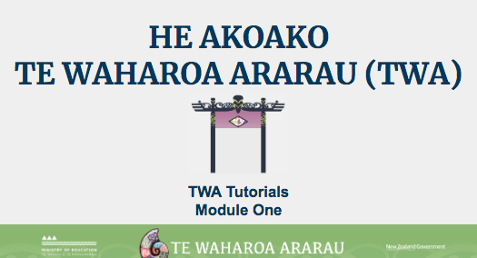 | Kei aku rangatira huri noa i Aotearoa e mātaki mai ana, tēnā tātou katoa.  Nau mai ki tēnei akoako poto e pā ana ki te whakahoutanga o Te Waharoa Ararau.
Slide 2  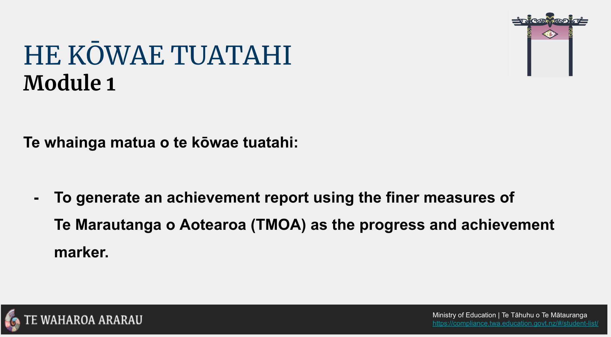 | In this tutorial, we’re going to show you how to generate an individual report using TMOA as the progress and achievement marker.
Slide 3  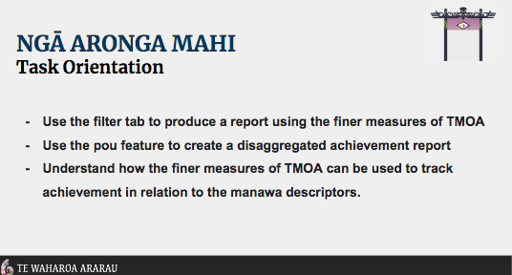 | By the end of this tutorial you should be able to independently:  - Use the ‘Ngā Tātaringa’ filter tab to produce a report using TMOA levels as the progress and achievement marker.  Let’s take a closer look at how this is done through the Pūrongo Tab.
LIVE to Purongo Tab  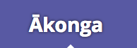 | The default landing view in the Pūrongo Tab is the Kura sub-tab.  Click on the Ākonga sub-tab to open settings to generate individual ākonga progress and achievement reports.
TMOA Progress Report  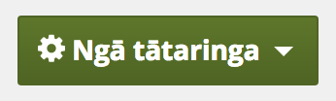  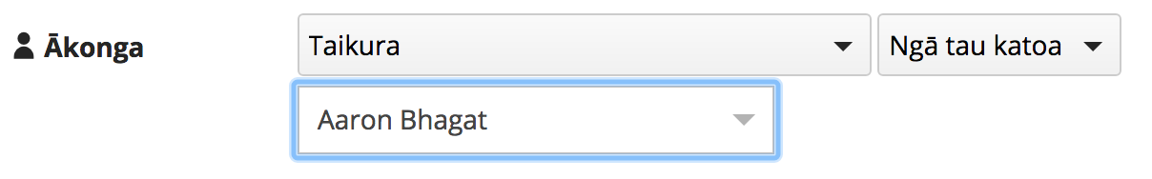  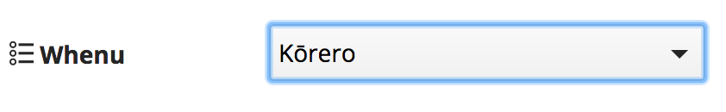  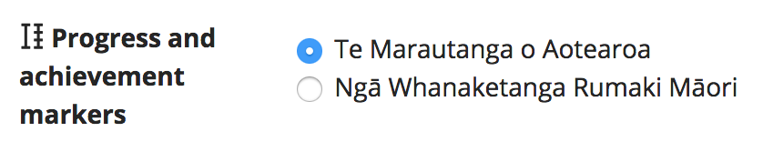  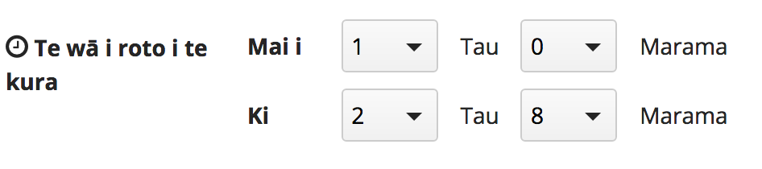  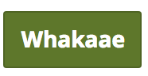 | Click the Ngā Tātaringa filter tab to select he group and ākonga you want to make a progress report for.  For this example we are selecting the Taikura Group and Aaron Bhagat as our ākonga.  Use the dropdown arrow to select the whenu you wish to generate a report for.  NOTE: The default whenu is Kōrero.  We are going to select TMOA to generate the new look progress and achievement report using TMOA taumata.  The last filter option in this window is,  Te wā i roto i te kura - remember to select the timeframe you want to view progress in.  Don’t forget to click the ‘Whakaae’ button!  The graph that is generated from the filters selected will show all OTJs in relation to TMOA taumata that have been entered within the timeframe selected.  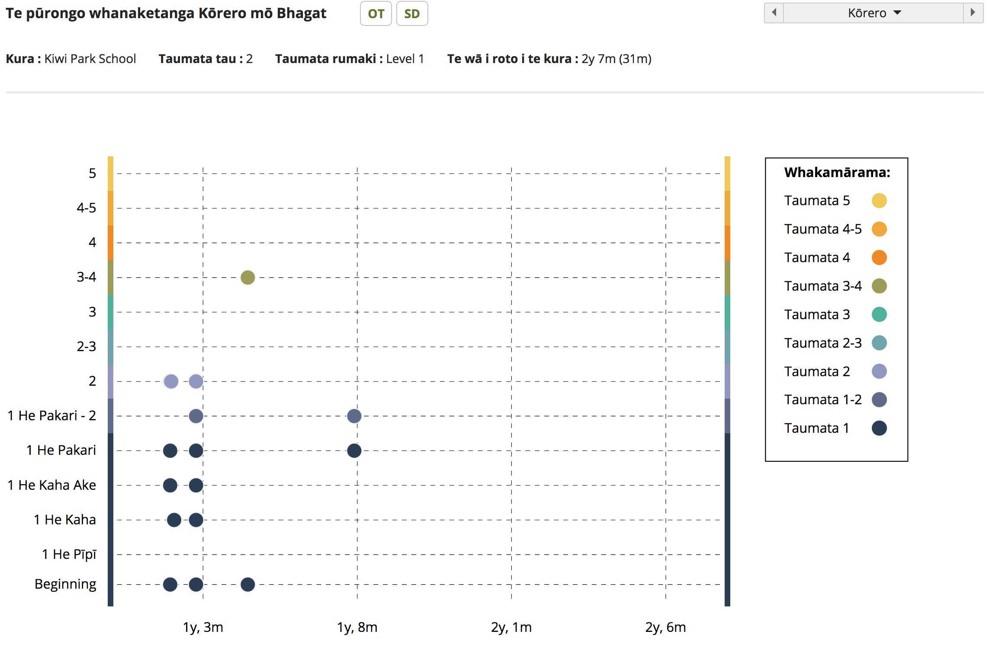  Below the graph there is also a chronological record of OTJs entered.  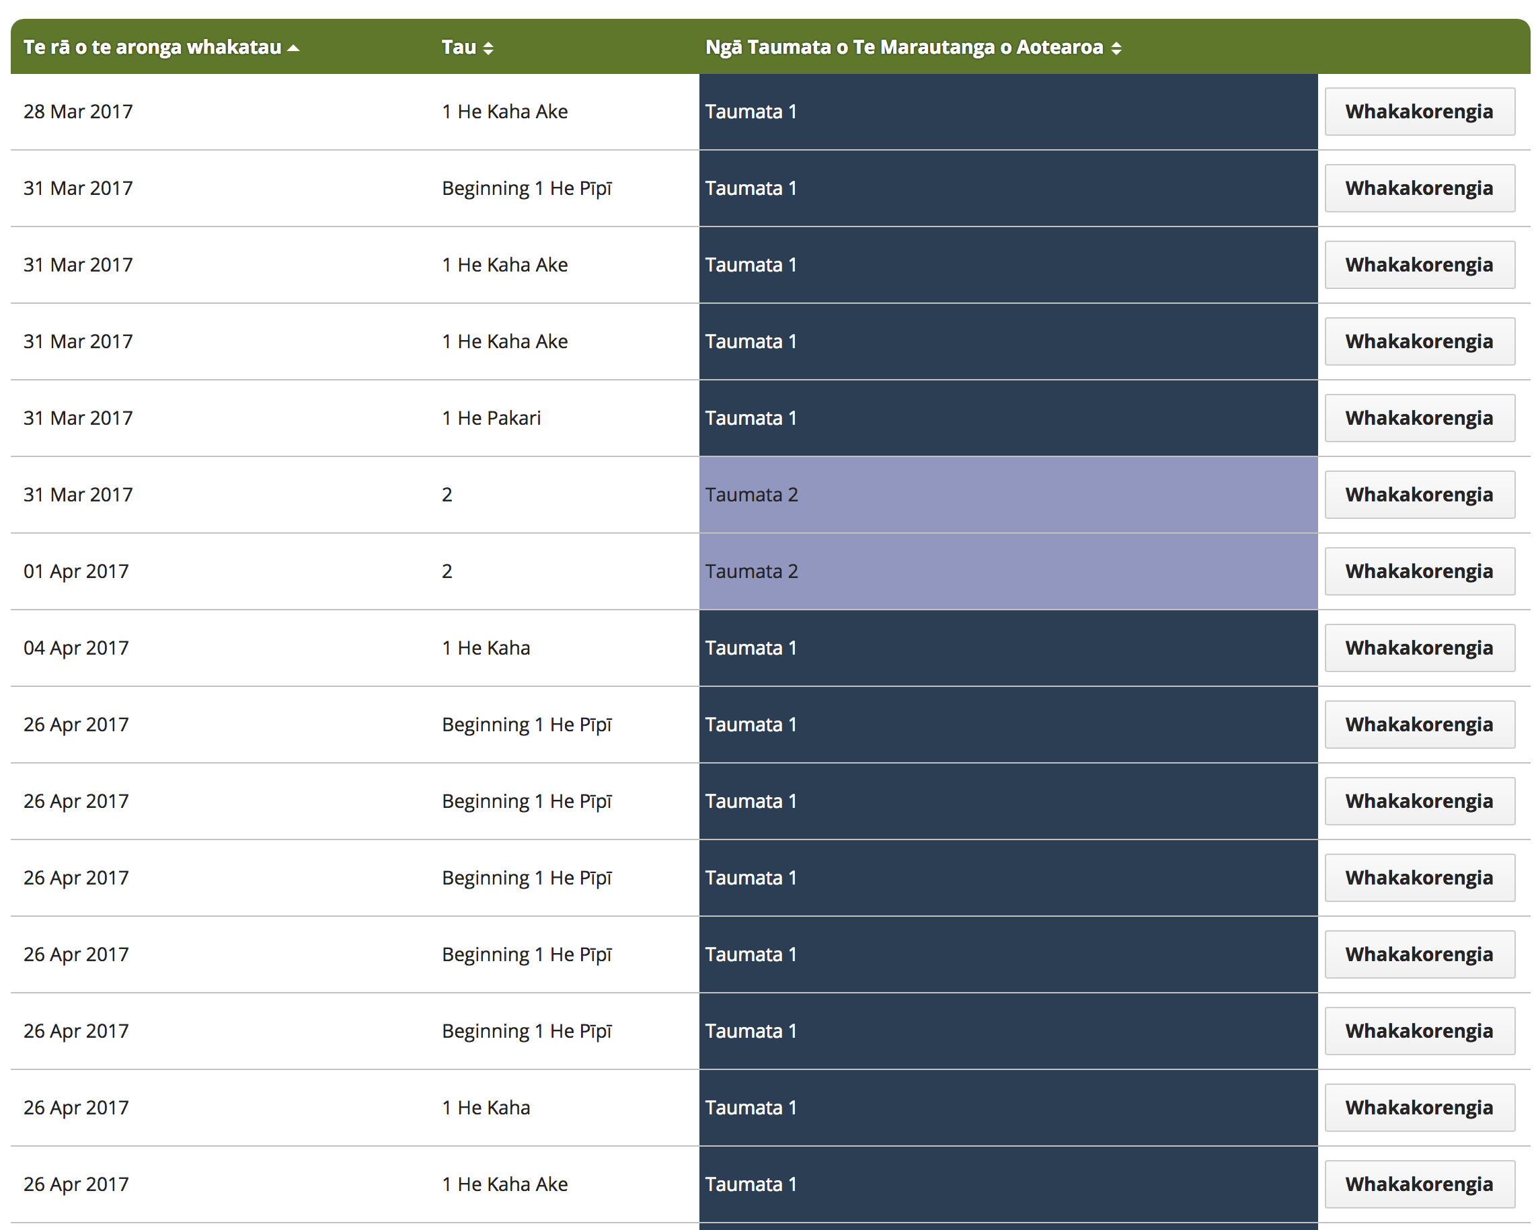
Slide 5  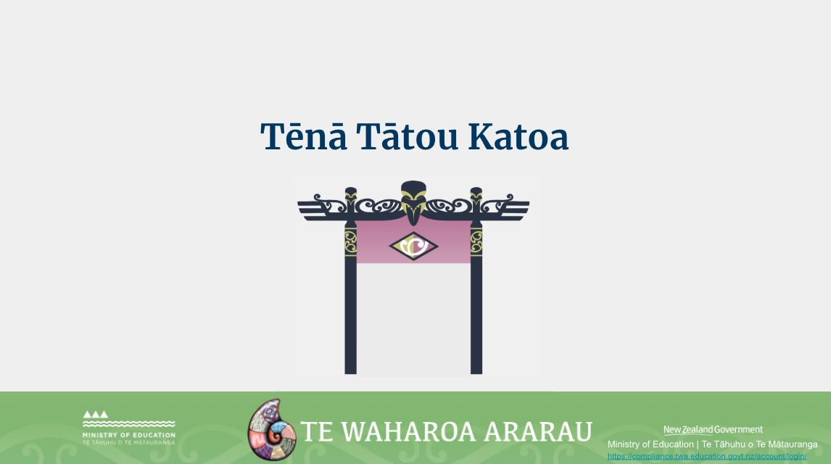 | Ko te manako ia, kua whai hua koutou i tēnei akoako poto me ngā kai o roto.  Nei rā anō te mihi manahau ki a koutou katoa.

